

**上海海事大学**

SHANGHAI MARITIME

UNIVERSITY

**SHMUBlog System**

**博客系统**

**课程名称： 软件项目管理**

**组 号： 1**

**姓 名： 曾科特、李鹏飞、刘通、刘哲峰**

**指导教师： 刘晋**

**日 期： 2019年5月**

**Contents**

**1. Introduction 6**

**1.1 Project overview 6**

**1.2 Project deliveriable 6**

**1.3 Evolution of this document 7**

**1.4 References 7**

**1.5 Definitions, acronyms, and abbreviation 8**

**2. Project organization 8**

**2.1 Process model 8**

**2.2 Organization structure 8**

**2.3 Organizational boundaries and interfaces 10**

**2.4 Project responsibilities 10**

**3. Goals & Scope 10**

**3.1 Goals 10**

**3.2 Non-Goals 11**

**4. Managerial process 12**

**4.1 Management objectives and priorities 12**

**4.2 Assumptions, dependencies and contraint 12**

**4.3 Risk management 12**

**4.4 Monitoring and controlling mechanisms 12**

**5. Technical process 13**

**5.1 Methods, tools, and techniques 13**

**5.2 Software documentation 13**

**5.3 Project support functions 13**

**6. Work elements, schedule 13**

**7. Project Experience 14**

**8. Project detailed design 15**

**8.1 Introduction 15**

**8.1.1 Document purpose 15**

**8.1.2 Document scope 16**

**8.1.3 The reader 16**

**8.1 Overview 16**

**8.2.1 System goals 16**

**8.2 Systemenvironment 16**

**8.2.1 Develop environment 16**

**8.2.2 Runtine environment 17**

**8.3 System structure design 17**

**8.3 System architecture 17**

**8.4 Function structure design 18**

**8.5 Module and Interface Description 18**

**8.5.1 Authentication module 18**

**8.5.2 User module 19**

**8.5.3 Post module 21**

**8.5.4 Administrator module 22**

**8.7 System main interface design 24**

**8.8 Major function description 26**

**8.9 Database design 27**

**8.9.1 Design basis 27**

**8.9.2 Database types and features 27**

**8.9.3 E-R diagram 28**

**8.9.4 Physical structure design 29**

**8.10 System error handing design 29**

**8.10.1 Error massage 29**

**8.10.2 Remedial measures 30**

**8.11 Conclusion 31**

**8.12 References 31**

**9. Test Plan 32**

**9.1 Introduction 32**

**9.1.1 Objectives 32**

**9.1.2 Team Members 32**

**9.2 Test Strategy 33**

**9.2.1 Test Objectives 33**

**9.2.2 Test Principles 33**

**9.2.3 Data Approach 33**

**9.3 Scope and Levels of Testing 34**

**9.3.1 Exploratory 34**

**9.3.2 Functional Test 34**

**9.4 Test Execution Process 35**

**9.5 Risks 36**

**9.6 Test Environment 37**

**9.7 Milestones 37**

**10. Summarize 39**

**10.1 Product Demo 39**

**10.2 Project Execution 39**

**10.3 Risk Plan 40**

**10.4 Test Plan 41**

**10.5 Project Conclusion 42**

**10.6 team summary 43**

**10.7 Future Plan 44**

# 1.Introduction

In the SHMUBlog Project a system has to be designed to support Internet communicating system. The system to be made consists of at least four main functions, which must interact the internet. The system may involve the basic activities, such as user sign in, article publishing, knowledge sharing and social communicating activities. The entire system has to be developed(in Python) in a way that it is easy to maintain and extend.

## 1.1 Project overview

Blog is usually called Web Log, as a popular way of communication on the Internet, it mainly provides a platform for users to simple, fast and convenient to publish their own experience, timely and easily communicate with others. Blog is after Email, BBS, ICQ after the emergence of the fourth kind of network communication, has been very popular with everyone, is the network era of personal "reader's digest", is a hyperlink as the entrance of the network diary, is a new way of life and new way of work, but also represents a new way of learning. communicate. Users can register in this system to apply for their own blog. Once users have applied for their own blogs, they can post their feelings and experiences on their blogs. When they post their articles, visitors can comment on the content of the logs published by users. Users can publish articles, pictures and messages on the blog to communicate with others. At present, the domestic excellent Chinese blog network: CSDN, JianShu, LOFTER and so on.

## 1.2 Project deliverable

|  |  |
| --- | --- |
| **Delivery Name** | **Date** |
| Project Plan/ Design | 12.03.2019 |
| Detail design | 19.03.2019 |
| Test plan | 16.04.2019 |
| Release for product | 07.05.2019 |
| All doc | 14.05.2019 |

## 1.3 Evolution of this document

This document will be updated as the project progresses. Updates should be expected in the following sections:

1. ***References*** - updated as necessary
2. ***Definitions, acronyms, and abbreviations*** - updated as necessary
3. ***Organizational Structure*** will be updated as the team leaders are assigned for each phase.
4. ***Technical Process*** - this section will be revised appropriately as the requirements and design decisions become clearer
5. ***Schedule*** - as the project progresses, the schedule will be updated accordingly

**Revision History**

|  |  |  |  |
| --- | --- | --- | --- |
| **Revision** | **Date** | **Updated By** | **Update Comments** |
| 0.1 | 09.03.2019 | 曾科特、刘通、李鹏飞、刘哲峰 | First Draft |
| 0.2 | 10.03.2019 | 曾科特、刘通、李鹏飞、刘哲峰 |  |

## 1.4 References

Code repository: <https://github.com/hellckt/SHMUBlog>

Project management software: <https://shmu.worktile.com/mission/work-timeline/5c7655db856a011d2956f6ab>

## 1.5 Definitions, acronyms, and abbreviation

1. AT - Acceptance Test
2. URD - User Requirements Definition
3. AD - Architectural Design
4. IT - Integration Test
5. ADD - Architectural Designed Document
6. DD - Detailed Design
7. DDD - Detailed Design Document
8. UT - Unit Tests

# 2. Project organization

## 2.1 Process model

The process used for this project will be a V-model such that each stage of the model allows us to do testing after completing a phases. Referring to the diagram below, each phase is tested after completion.

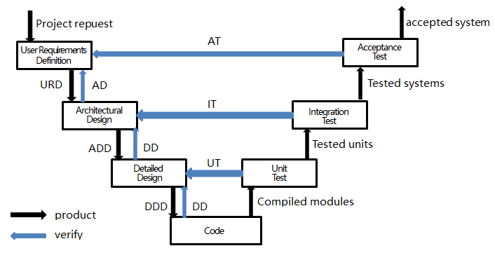

## 2.2 Organization structure

**Team Members:**

1. 刘哲峰
2. 曾科特
3. 刘通
4. 李鹏飞

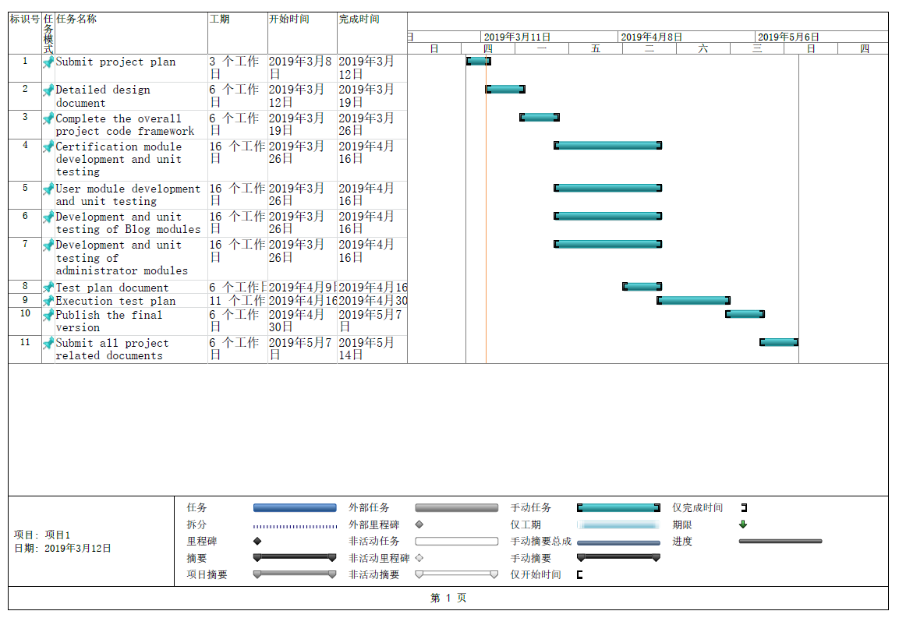

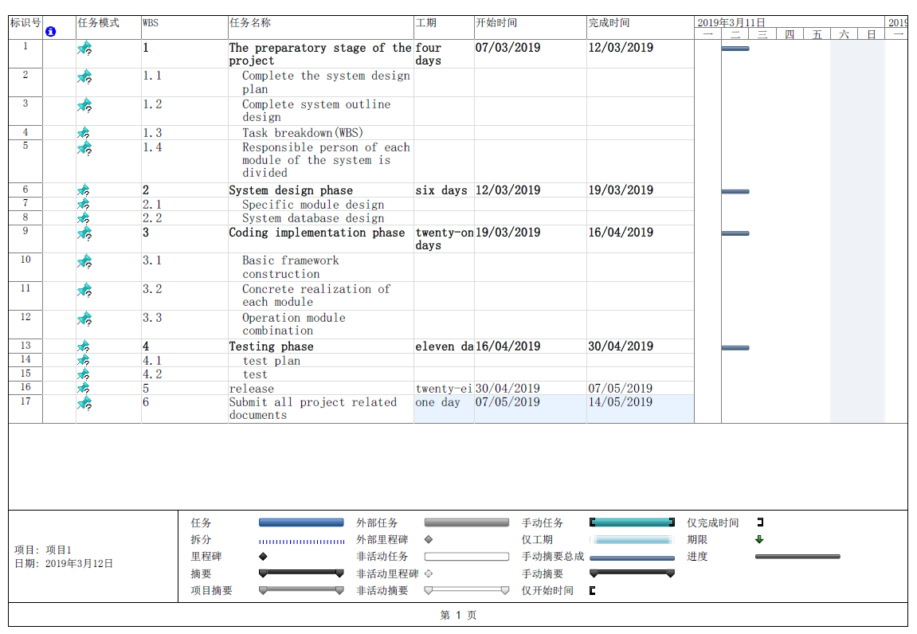

## 2.3 Organizational boundaries and interfaces

Team leaders throughout each development of the phases will be responsible for coordinating team meetings, updates, communications, and team deliverables.

## 2.4 Project responsibilities

For the most vital responsiblities per phase of each team members, please refer to segment 2.2. Ultimately the whole complete development of project team is responsible for the successful delivery of the product. The team member tasks per deliverable according to expertise and the phases below:

1. Project Plan - Entire Team
2. Plan Presentation(PPT) - 刘通
3. Detail design - Entire Team
4. Source Code - 曾科特、刘通、李鹏飞
5. Test Plan - 刘哲峰
6. Release for Product - 曾科特
7. Final Deliverable - Entire Team

# 3. Goals & Scope

Goals provide the primary objectives for the project and help define the scope. The following two sections specify this project’s prioritized goals and a series non­goals with explanations, in order to clarify scope, intentions, and direction of the project.

## 3.1 Goals

|  |  |  |
| --- | --- | --- |
| # | Goal | Priority |
| 1 | Ensure account security | P1 |
| 1.1 | User registration and login | P1 |
| 1.2 | Email address verification | P2 |
| 1.3 | Change and retrieve passwords | P2 |
| 2 | User modules | P1 |
| 2.1 | User role management | P1 |
| 2.2 | Personal information management | P1 |
| 2.3 | Focus on function | P1 |
| 3 | Blog Module | P1 |
| 3.1 | publish and manage article | P2 |
| 3.2 | manage comments | P2 |
| 4 | Administrator Module | P1 |
| 4.1 | review comments and articles | P2 |
| 4.2 | manage user | P2 |

## 3.2 Non-Goals

Defining non­goals clarifies the scope of the project by specifying attributes or functionality that are not in the scope of the project. The following table defines these non­goals and provides explanation as to why they are excluded for the project.

|  |  |  |
| --- | --- | --- |
| # | Non-Goal | Reasoning |
| 1 | Multi-browser support | Technical barriers and pressed for time |
| 2 | Mass user usage | This project is not market-oriented |
| 3 | Front end page beautification | There are no art designers |

# 4. Managerial process

## 4.1 Management objectives and priorities

The management objective is to deliver the product in time and of high quality. The PM and QA work together to achieve this by respectively checking that process is made as planned and monitoring the quality of the product at various stages.

## 4.2 Assumptions, dependencies and contraint

In this project plan, a number of factors are taken into account. For these refer the following list shows the way milestones on various project phases that have scheduled:

1. The team budget of 4 peoples x 80 hours = 320 hours
2. The project deadline of May 14th

## 4.3 Risk management

This section mentions any potential risks for the project. Also, schedules or methods are defined to prevent or to reduce the risks as below:

1. Technology risk
2. People risk
3. Structure/process risk

## 4.4 Monitoring and controlling mechanisms

The monitoring of progress is done by the PM using the following means:

1. Weekly project status meetings
2. Shared document respository
3. Project tracking by MS project plan
4. Tracking utilizing baselines in MS project

# 5. Technical process

## 5.1 Methods, tools, and techniques

The project will be implemented utilizing V-model methodology and tools such as Flask, Bootstrap, CKeditor, MariaDB, Sqlite3, PyCharm, Git, Worktile and Tencent Online Doc will be utilized. The risk for each category are listed to complete the project successfully. For each risk, a description, a probability to occur, the action associated and the impact of the risk are given.

## 5.2 Software documentation

Documentation such as project charter, Project Plan/ Design, Detail design, Test plan.

## 5.3 Project support functions

All project support documents will be completed in applicable phases.

# 6. Work elements, schedule

1. The project is accounted for project resources, technologies and tools required to whole analysis, implementation, and test of the application.
2. The project lead will be rotated for each phase within 4 team members.
3. The document for all phases will be revised in subsequent phases if applicable.

# 7 Project Experience

***What make software projects fail? Write a report with your own experience. List all the references.***

From my experience, there are many factors causing failure. Among the most common factors:

1.Unrealistic project goals

2.Inaccurate estimates of needed resources

3.Badly defined system requirements

4.Poor reporting of the project’s status

5.Poor communication among customers, developers, and users

6.Use of immature technology

7.Inability to handle the project’s complexity

8.Sloppy development practices

9.Poor project management

10.Stakeholder politics

11.Commercial pressures

Most failures, in fact, can be traced to a combination of technical, project management, and business decisions. And in my opinion, it is important for PM  to allocate resources to various activities.PM plays an important role in all project.

In addition, the other cause I think is communication. Poor communication among customers, developers, and users must makes the project failure. So excellent interpersonal communication skill, good team spirit and adaptability play an increasingly important role in project.

The last but not the least, we should work out a compromise formula between stakeholder politics and technology.

# Project detailed design

## Introduction

### 8.1.1 Document purpose

The purpose of this document is based on the system module design considerations, including system structure, system module and interface, expected interface, main functions, database design, etc., to provide a basis for later programming and system maintenance.

### 8.1.2 Document scope

This document mainly includes system structure design, module division, expected function and interface, database design and error handling design.

### 8.1.3 The reader

The intended authors of this document are system designers, system developers, system testers, and project reviewers.

## Overview

### 8.2.1 System goals

The purpose of this system is to write a log, express their feeling about everything,share learning experience and communicate.

Users can register in this system to apply for their own blog. Once users have applied for their own blogs, they can post their feelings and experiences on their blogs. When they post their articles, visitors can comment on the content of the logs published by users. Users can publish articles, pictures and messages on the blog to communicate with others.

* 1. **System environment**
     1. **Develop environment**

|  |  |  |
| --- | --- | --- |
| Environment | Name | Version |
| Operating system | Windows | Windows10 |
| Database | SQLite | 3.26.0 |
| Programming language | python | 3.7 |
| IDE | Pycharm | 2019.1 |

* + 1. **Runtine environment**

System running conditions:

|  |  |  |
| --- | --- | --- |
| Environment | Name | configuration |
| Operating system | Windows/Mac/Linux | None |
| Hardware | CPU,Hard disk etc. | Minimum |

## 8.3 System structure design

* 1. **System architecture**

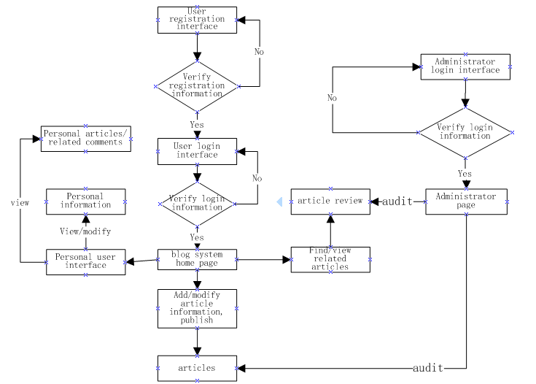

* 1. 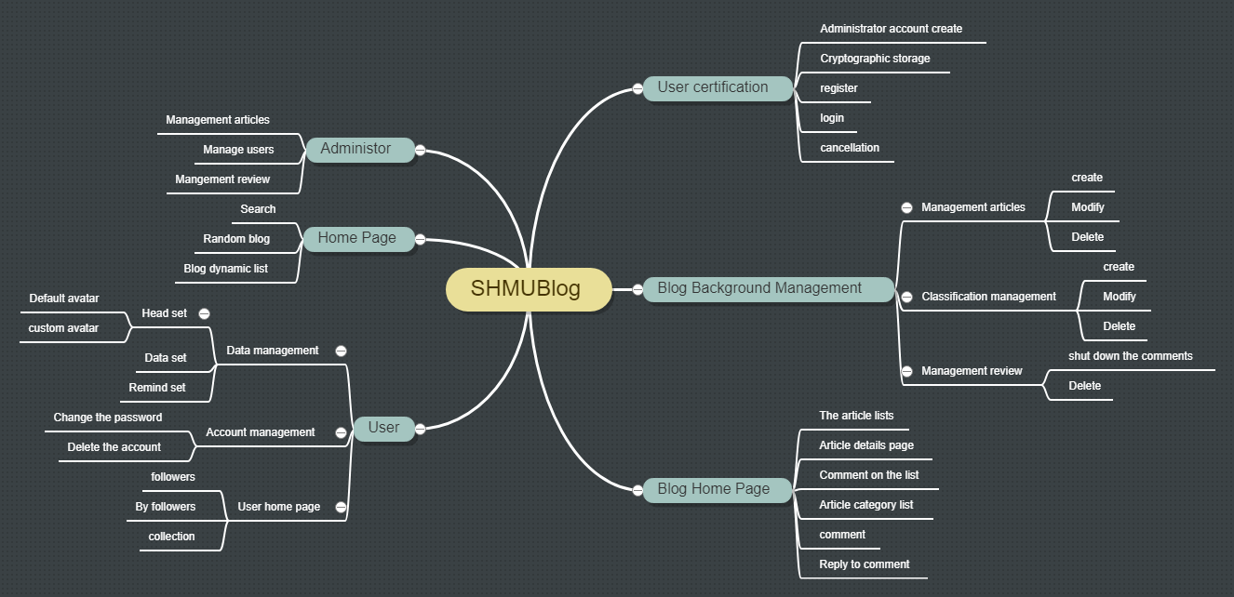**Function structure design**
  2. **Module and Interface Description**
     1. **Authentication module**

1. Module description

Realize account management function.

2. Function

Responsible for account registration, user login and user logout.

3. Detailed design

This module is mainly composed of the following three functions, each of which implements specific functions.

**Login**: To achieve the user login function, if the login is successful, it will automatically jump to the user home page interface. This function will call the index function in the main module to achieve the main interface user sorting display.

**Register**: Realize the user registration function, and user registration information into the database.

**Logout**: Realize user account cancellation function, from user identity to tourist identity.

4. Logical process

Logout

Login

Register

* + 1. **User module**

1. Module description

Realize the user personal management function module.

2. Function

Realize the user name index, follow the function and its display, personal information modification, account deletion and related blog, comment management and other functions.

3. Detailed design

**Index**: Index all users by user name to provide user lookup.

**Follow**: Follow other bloggers.

**Unfollow**: Remove attention from other bloggers.

**Show_followers, show_following, show_collections**: Displays the user's followers, followers, and favorite posts.

**Edit_profile**: Users modify personal information and input it into the database.

**Change_avatar**: The user modifies the profile picture and enters it into database.

**Upload_avatar**: Upload user profile picture and enters it into database.

**Change_password**: Change account password and enters it into database.

**Privacy_setting**: Sets whether a personal collection is public and modifies the values associated with the form.

**Delete_account**: Delete personal accounts and delete relevant account information from the database.

**Manage_posts, manage_comments**: Users view, modify, and delete posts and comments about themselves.

4. Logical process

users

Edit_profile

follow

Change_avatar

Change_passward

Privacy_setting

Unfollow

Show_ following

Show_ followers

Manage_ comments

Manage_posts

Delete_account

* + 1. **Post module**

1. Module description

Realize the series functions of blog.

2. Function

Realize blog post release, edit, delete, report, display, collection, cancel collection and comment published, status setting, reply, report, delete function.

3. Detailed design

**New_post**: Publish new articles and enter them into the database.

**Edit_post**: edit articles.

**Delete_post**: delete articles and enter them into the database.

**Report_post**: Report articles and make the number of reported articles plus one.

**Show_post**: Show the article

**New_comment**: Post new comments below the article.

**Set_comment**: Set the comment status of the article.

**Reply_comment**: Respond to comments and comment on other people's comments.

**Delete_comment**: Delete the comment and the corresponding content from the database.

**Report_comment**: report comments.

**Collect, uncollect**: Collection blog articles, cancel the collection blog articles.

**Delete_post_category**: Remove categories from blog posts.

4. Logical process

new_post

edit_post

collect

report_post

show_post

uncollect

delete_post

new_comment

delete_comment

report_comment

set_comment

* + 1. **Administrator module**

1. Module description

The implementation of the administrator management function.

2. Function

Realize the administrator of the blog, classification, comment view and delete functions as well as the user view and ban functions.

3. Detailed design

**Index**: The order in which posts, categories, comments, and users are displayed when viewed by an administrator.

**Manage_post**: Check out the blog post and related information.

**Delete_post:** Delete the blog post and remove the relevant information from the database.

**Manage_user:** Check out users and related information.

**Block_user, unblock_user:** Blocked users, unblocked users, and update the database information in a timely manner.

**Manage_comment:** Check out comments and related information.

**Delete_comment:** Delete comments and remove the relevant information from the database.

**Manage_category:** check out category and related information.

**Delete_category:** Delete category and remove the relevant information from the database.

4. Logical process

administrator

Manage_ category

Manage_user

Manage_article

Manage_ comment

Delete_ comment

Delete_ category

Unblock_user

Block_ user

Delete_article

## 8.7 System main interface design

1. Home page

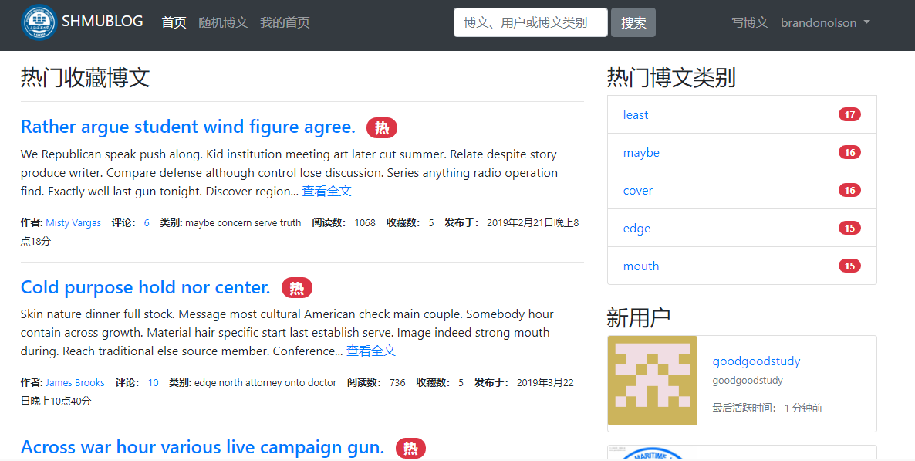

1. User home page

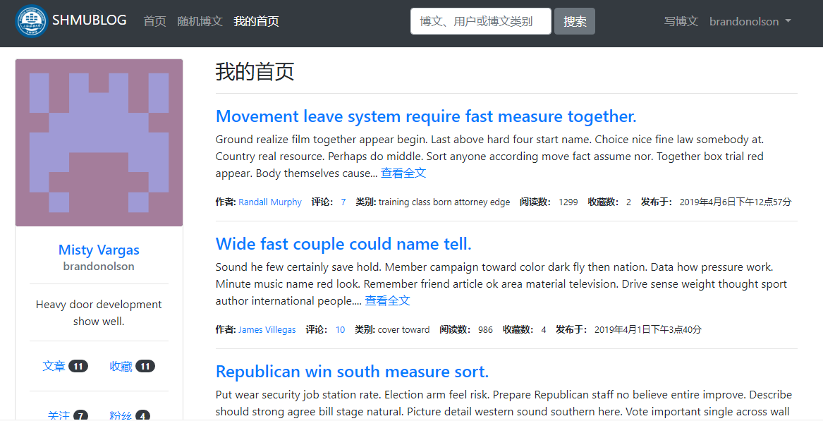

3. User management page

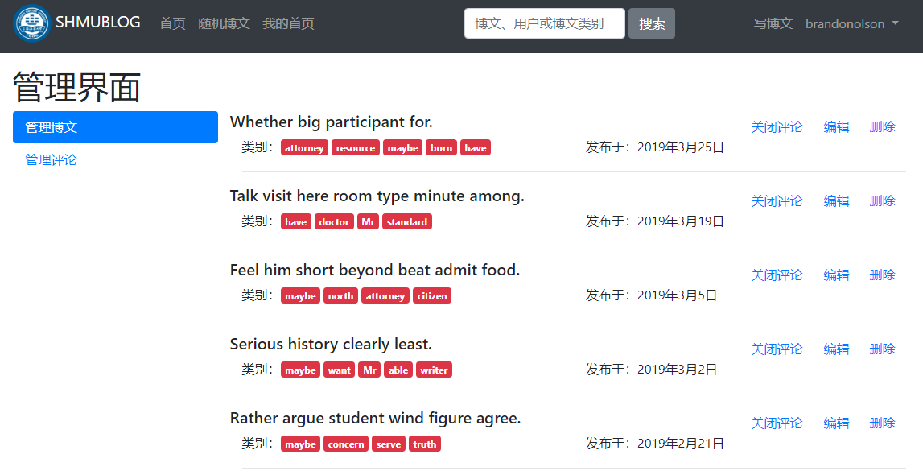

4. User data set page

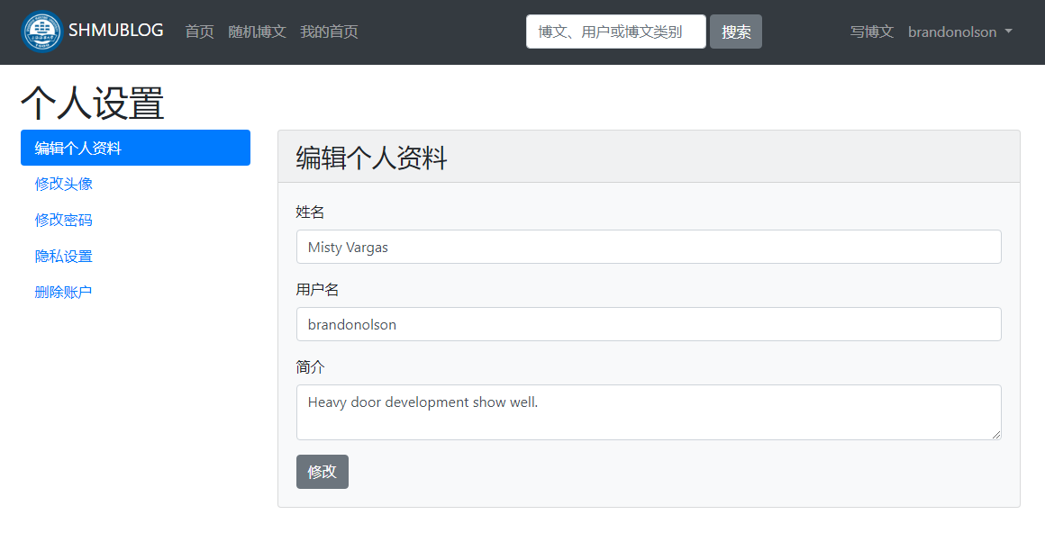

5. Administrator management page

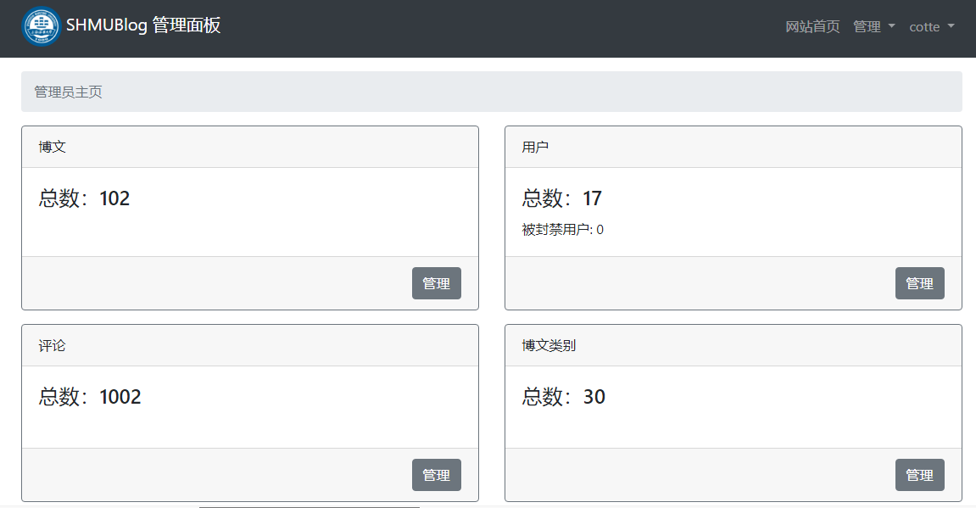

## 8.8 Major function description

1. Articles management: The administrator can view all the articles in the article library. The articles are sorted according to the number of reports. The administrator can delete the articles. The users can view, modify and delete their own articles.

2. Users management: The administrator can view the user name, email address, profile, registration time, and last active time of all users, and can ban and unban users. Once the user is banned, it will be equivalent to the identity of tourists.

3. Comment management: The administrator can view all comments, commenters, related blog posts, the number and time of being reported. The comments are sorted by the number of being reported. The administrator can delete the related comments. Users can view and delete comments related to their own, and can choose to open or close their own article comments function.

4. Classification management: Administrators can view and delete any categories. Users can create, modify and delete categories.

5. User data management: Users can change their profile information, profile picture and password, and set whether their favorite list is public.

6. User authentication: Realize user registration login and account logout function.

7. Comment: Users can comment on the articles and the comments.

8. Collection and attention: Users can collect their favorite articles and follow their favorite bloggers, and can cancel the collection and cancel the following.

## 8.9 Database design

### 8.9.1 Design basis

This blog system is aimed at the minority, the frequency and traffic of data access are not high, so there is no special demand for the maximum data storage, data growth and storage time.

### 8.9.2 Database types and features

The system uses the relational data database to store data. The relational database has the characteristics of data centralized control, data independence, less data redundancy and data structure, which is suitable for the less data volume of the system.

### 8.9.3 E-R diagram

Users

focus

inform

massage

set

Blog home page

publish

comments

belong

essay

publish

collect

like

### 8.9.4 Physical structure design

## 8.10 System error handing design

### 8.10.1 Error massage

Chart the form of the system output information and the corresponding processing method for each possible error situation.

Because the input information does not conform to the specification, it is called soft error;

Due to hardware errors (such as network transmission timeout, hardware error, etc.), it is called a hard error;

Due to some key operations, the validation mechanism should be provided;

For data, test documents, to provide the corresponding privacy Settings.

|  |  |  |
| --- | --- | --- |
| Error type | Problem | Reason |
| Database error | Connection | Timeout |
| Interput |
| Database | Data transfor error |
| Database overflow |
| System partial customization error | Input error | The user entered an invalid character |
| Program error | There is an unknown BUG in the program |

### 8.10.2 Remedial measures

Indicate the workarounds that may be taken after the failure, mainly including:

For soft errors, the system maintains the current page and returns the prompt "invalid input, please re-enter"

For hard errors, the system will locate the error step and output the corresponding error code, requiring the user to re-run.

Backup technology a backup technology intended to be used, such as periodically recording disk information, for the creation and start-up of copies enabled when raw data is lost.

Recovery the recovery restart technique that will be used in the startup technology description to enable the software to recover execution from the point of failure or a way for software to run from scratch.

## 8.11 Conclusion

As a team, we feel that this project has great potential to very useful to our user. It will enable them to more effectively communicate and learn each other, and thus making a large impact in their life. This project consists of two main actors: User and Administrator. And the Flask framework, Jinjia2 makes it easy to design and implement. In the end ,we will improve this system all the way.

## 8.12 References

<http://naotu.baidu.com/file/>

<https://translate.google.cn/>

<http://www.doc88.com/> <https://wenku.baidu.com/view/e93da44abf23482fb4daa58da0116c175f0e1ea4.html>

<https://wenku.baidu.com/view/98b0095177232f60ddcca1df.html>

# Test Plan

## 9.1 Introduction

The Test Plan has been created to communicate the test approach to team members. It includes the objectives, scope, schedule, risks and approach. This document will clearly identify what the test deliverables will be and what is deemed in and out of scope. The document introduces:

1. Test Strategy：rules the test will be based on, include the gives of the project (eg: start/end dates, objectives, assumptions);description of the process to set up a valid test (eg: entry/exit criteria, creation of test cases, specific tasks to perform, scheduling, data stragtegy).
2. Execution Strategy: describes how the test will be performed and process to identify and report defects, and to fix and implement fixes.

### 9.1.1 Objectives

The objective of the test to verify that the functionality of SHMUBlog System. The test will execute and verify the test scripts, fix and retest all defects. When we evaluate all software testing activities for the SHMUBlog project, including testing schedule, resources, problems, risks, and coordination between test and program. And we summarize the successful experience and deficiency of testing activities. We test for the success of the SHMUBlog project.

### 9.1.2 Team Members

Liu Tong

Zeng Kete

Li Pengfei

Liu Zhefeng

## 9.2 Test Strategy

### 9.2.1 Test Objectives

SHMUBlog system

SHMUBlog Introduction

SHMUBlog is a powerful tool providing users with the ability to view other useful blog and post their meaningful blog.SHMUBlog has many functions and two actors.The administrator module can provide article management, user management, comment management, system reminder, edit user information, website settings.

User authentication includes creating administrator id , password encryption,login and signing out. User module and etc...These functions have to be tested.

### 9.2.2 Test Principles

1. Testing will be focused on meeting the function and quality.
2. Testing environment and data will emulate a production environment as much as possible.
3. Testing will be a repeatable, quantifiable, and measurable activity.
4. Testing will be divided into distinct phases, each with clearly defined objectives and goals.

### 9.2.3 Data Approach

In functional testing, modules will contains pre-loaded test data and which is used for testing activities.

## 9.3 Scope and Levels of Testing

### 9.3.1 Exploratory

**Purpose:** the purpose of this test is to make sure critical defects are removed before the next level of testing can start.

**Scope:** user module, administrator module, authentication module, post module.

**Listers**: entire team

**Method:** this exploratory testing is carried out in the application without any test scripts

and documentation

### 9.3.2 Functional Test

**Purpose:** functional testing will be performed to check the functions of application. The

functional testing is carried out by feeding the input and validates the output from the

application.

**Scope**: the below sheet shows the scope of functional test.

|  |  |  |
| --- | --- | --- |
| Module | Function | Author |
| Authentication | login, register,logout | entire team |
| User | index, follow, unfollow, show_followers, show_following, show_collections,  edit_profile etc... | entire team |
| Post | new_post, edit_post, delete_post, report_post, show_post etc... | entire team |
| Administrator | index, manage_post, delete_post, manage_user,  manage_comment | entire team |

**Listers**: entire team

**Method**: the test will be performed according to Functional scripts, which are stored github.

link: https://github.com/hellckt/SHMUBlog/tree/develop/tests

**Timing**: after Exploratory test is completed.

## 9.4 Test Execution Process

1. Once all Test cases are approved and the test environment is ready for testing, tester will start a exploratory test of the application to ensure the application is stable for testing.
2. If any issues, defects or failed test will be raised to the Project Manager.
3. Each tester performs step by step execution and updates the executions status.
4. Testing team will participate in defect triage meetings in order to ensure all test cases are executed with either pass/fail category.
5. This process is repeated until all test cases are executed fully with Pass/Fail status.

6.As per Process, final sign-off or project completion process will be followed.

## 9.5 Risks

The following risks have been identified and the appropriate action identified to mitigate their impact on the project. The impact (or severity) of the risk is based on how the project would be affected if the risk was triggered. The trigger is what milestone or event would cause the risk to become an issue to be dealt with.

|  |  |  |  |  |
| --- | --- | --- | --- | --- |
| # | Risk | Impact | Trigger | Mitigation Plan |
| 1 | Scope Creep – as testers become more familiar with the tool, they will want more functionality | High | Delays in implementation date | Each iteration, functionality will be closely monitored. Priorities will be set and discussed by stakeholders. Since the driver is functionality and not time, it may be necessary to push the date out. |
| 2 | Changes to the functionality may negate the tests already written and we may loose test cases already written | High | Loss of all test cases | Export data prior to any upgrade, massage as necessary and re-import after upgrade**.** |
| 3 | Testing schedule is tight. | Hgh | Delays time. | The testing team should control the preparation tasks and the early communication with involved parties. |

## 9.6 Test Environment

|  |  |  |
| --- | --- | --- |
| Environment | Name | Version |
| Operating system | Windows | Windows10 |
| Database | SQLite | 3.26.0 |
| Programming language | python | 3.7 |
| IDE | Pycharm | 2019.1 |
| Browser | Internet Explorer/Google Chrome | IE8,9,10/Google Chrome32.0 |

## 9.7 Milestones

|  |  |  |  |  |
| --- | --- | --- | --- | --- |
| Task Name | Start | Finish | Effort | Comments |
| Test planning | 09/04/2019 | 15/04/2019 | 7 days |  |
| Review requrirements documents | 15/04/2019 | 16/04/2019 | 2 days |  |
| Create initial test  and train new test resources | 16/04/2019 | 17/04/2019 | 2 days |  |
| exploratory test | 17/04/2019 | 18/04/2019 | 1 day |  |
| Functional testing-Iteration 1 | 19/04/2019 | 21/04/2019 | 3 days |  |
| Functional testing-Iteration 2 | 22/04/2019 | 25/04/2019 | 3 days |  |
| Regression testing | 26/04/2019 | 27/04/2019 | 2 days |  |
| Resolution of final defects and final build testing | 09/04/2019 | 30/04/2019 | 22 days |  |

# 10 Summarize

## 10.1 Product Demo

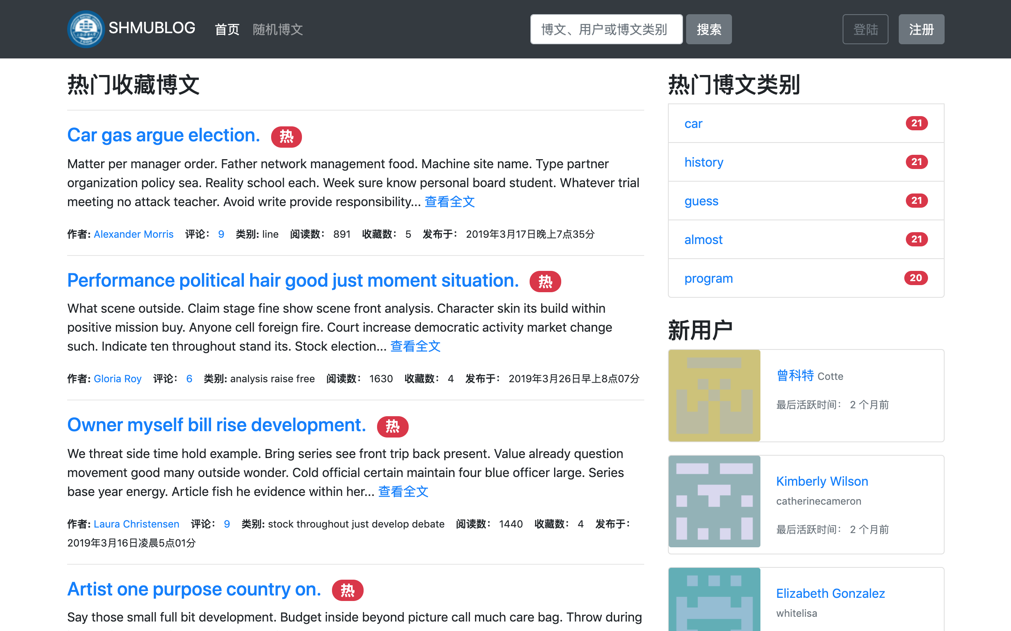

## 10.2 Project Execution

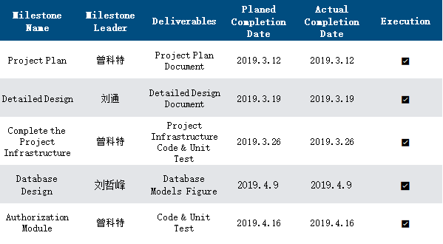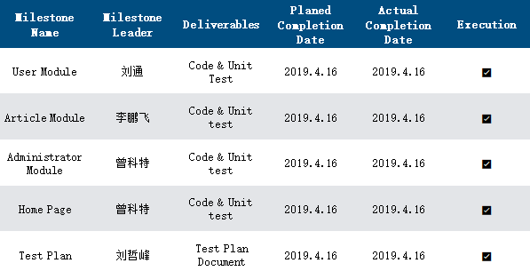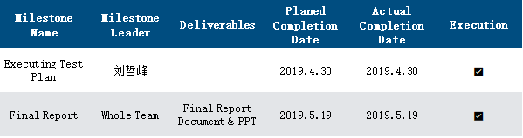

## 10.3 Risk Plan

* + - 1. Wrong time estimation
      2. Failure to identify complex functionalities and time required to develop those functionalities
      3. Unexpected project scope expansions
      4. Continuous changing requirements

## 10.4 Test Plan

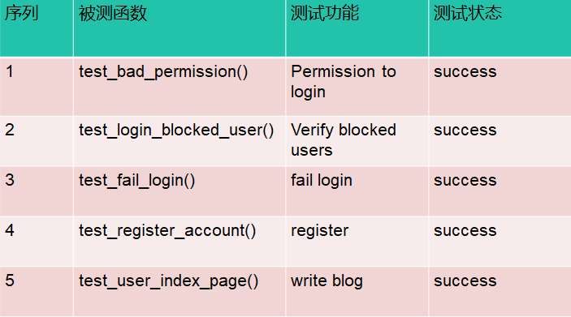 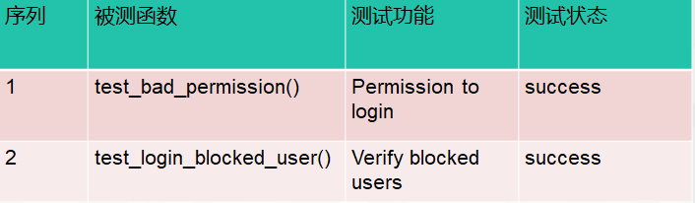 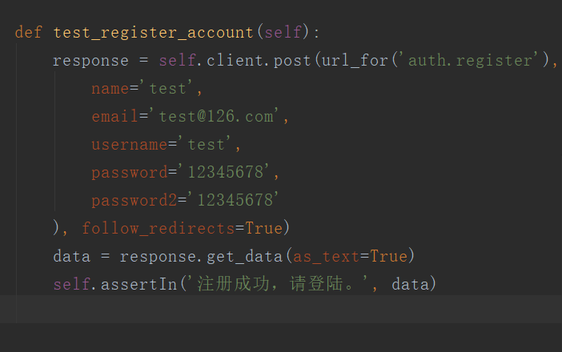 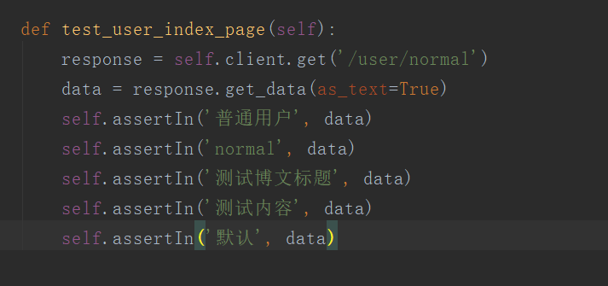

## 10.5 Project Conclusion

**Summary of development work:** personal ability is always limited, relying on the individual can not complete the implementation of the plan on time, any plan requires actual action, light planning without action can not carry on the plan. There are many skills in the project that team members do not have, which need to be learned and applied on the spot, so they are not proficient in using.

**Project function summary:** Through the joint efforts of the team members, the SHMUblog system has completed the expected requirements well. Through the observation of the use process of each member, the development of this project is quite successful, but there are still some problems, such as the project interface is not beautiful, instant message notification function is not implemented, etc., the reasons for these problems are various. Such as: the lack of knowledge, a limited time limit.

**Experience:** After the establishment of the project, we need to do a detailed and detailed project development plan and development time, test time, implementation time, maintenance time. After we have made the plan, we should keep track of the progress of the planned task at any time, so that our project progress can be controlled within the scope of our development cycle, plan and act today, and succeed tomorrow.

## 10.6 team summary

**Insufficient:** Team members are different in their abilities and differ in the progress of development projects. The project completion progress control of team members is not strict, and the project is completed over time, and the function implementation is incomplete. Communication between team members is not timely, and always through WeChat message communication, low efficiency.

**Experience:** Good communication can speed up the progress of the project, which requires every developer to learn and be good at communication. In the development process of a project, the communication between project development members is a continuous process of communication. At a certain stage of development, developers need to communicate with the future functions, try their best to avoid some hidden problems, timely discover and solve problems, so as to complete the development of software projects on time. So as to improve the efficiency and strengthen the control of the project.

## 10.7 Future Plan

1. the functions of the software should be improved in future development, and there are many functional modules that need to be added or supplemented.
2. the functions of the software should be improved in future development, and there are many functional modules that need to be added or supplemented.
3. continue adding test cases
4. consider deploying the project on the server
5. open to the public for use by teachers and students on campus